**Bi-directional Recurrent Neural Network:**

* A Bidirectional Recurrent Neural Network (BRNN) is an architecture designed to process sequential data by analyzing it in both forward and backward directions.
* BRNNs consist of two recurrent hidden layers: one processes the sequence forward (from start to end), and the other processes it backward (from end to start).
* These hidden layers can use RNN variants like Long Short-Term Memory (LSTM) or Gated Recurrent Unit (GRU) cells. The outputs from both layers are combined and passed to a final layer for prediction.

**Diagram:**

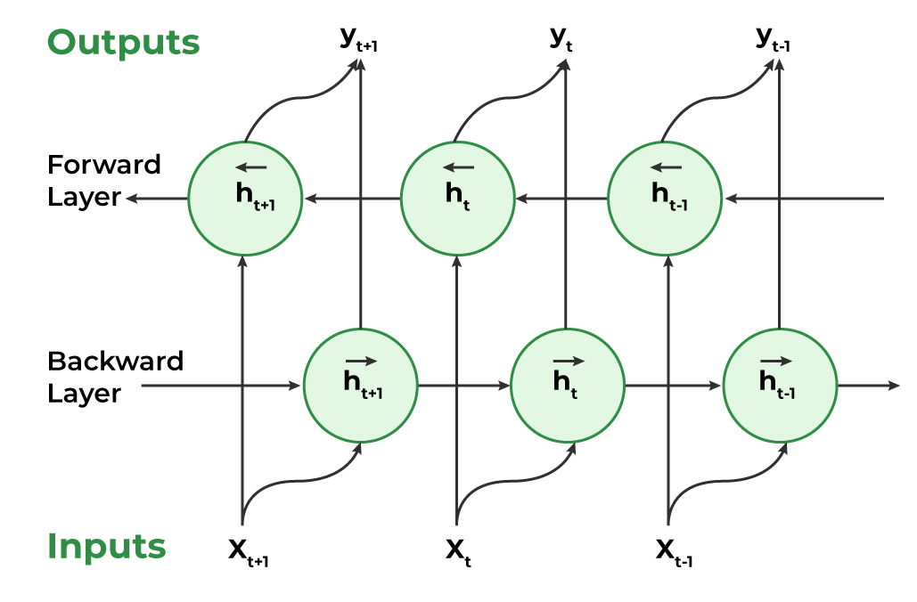

**Working of Bidirectional Recurrent Neural Network (BRNN)**

1. **Input:**
   * A sequence of data points, represented as vectors of uniform dimensions, is fed into the BRNN.
   * The sequence can vary in length, making BRNNs flexible for tasks like text, speech, and time-series analysis.
2. **Dual Processing:**
   * Forward Direction: The hidden state at time step *t* is calculated based on the input at step *t* and the hidden state from the previous step (*t-1*).
   * Backward Direction: Simultaneously, another hidden layer processes the sequence in reverse, where the hidden state at *t* is influenced by the input at step *t* and the hidden state from the next step (*t+1*).
3. **Hidden State:**
   * At each time step, both the forward and backward hidden states are computed using a non-linear activation function (e.g., sigmoid or tanh).
   * This memory is updated based on the current input and the previous hidden state (in forward direction) or the next hidden state (in backward direction).
4. **Output:**
   * The outputs from both forward and backward hidden layers are combined (e.g., concatenated or summed).
   * These combined results are used to calculate the final output using an activation function (a mathematical formula that introduces non-linearity).
   * This output can either serve as the final prediction or act as an input for another layer.

**Training a Bidirectional Recurrent Neural Network (BRNN)**

To calculate the hidden states and outputs in a BRNN, we use the following formulas:

**1. Hidden State Calculations:**

* **Forward Hidden State:**

Ht (Forward) = A(Xt * WXH (forward) + Ht-1 (Forward) * WHH (Forward) + bH (Forward)

* **Backward Hidden State:**

Ht (Backward) = A(Xt * WXH (Backward) + Ht+1 (Backward) * WHH (Backward) + bH (Backward)

where,

A = activation function,

W = weight matrix

b = bias

The final hidden state at time step t combines both forward and backward hidden states.

**2. Output Calculation:**

The output at time step t is calculated using the combined hidden states:

Yt = Ht * WAY + by

Where:

* WAY: Weight matrix from hidden states to output
* bY: Bias for output

3. Training the BRNN:

Training a BRNN uses Backpropagation Through Time (BPTT), but because BRNN processes sequences in two directions (forward and backward), training requires careful handling to avoid conflicts.

Training Steps:

1. **Roll Out the Network:**
   * Unfold the BRNN across time steps (like unrolling a loop).
   * Compute errors at each time step for both forward and backward passes.
2. **Calculate Gradients Individually:**
   * Gradients for the forward and backward passes are calculated separately to avoid overwriting each other.
3. **Update Weights Separately:**
   * First, update the weights for the forward direction using its gradients.
   * Then, update the weights for the backward direction using its gradients.
4. **Roll Up the Network:**
   * Fold the network back into its original structure after weight updates.

This separation ensures that the updates from forward and backward passes do not interfere, leading to more stable and accurate training.

By training the forward and backward passes individually, the BRNN can effectively learn patterns from both past and future contexts, improving overall performance on sequential data tasks.

**Applications of BRNNs:**

1. **Sentiment Analysis:** Understands emotions in text by analyzing words before and after.
2. **Named Entity Recognition**: Identifies names, locations, and dates using full sentence context.
3. **Part-of-Speech Tagging:** Classifies words (e.g., noun, verb) using surrounding words.
4. **Machine Translation:** Translates text accurately by understanding both directions of a sentence.
5. **Speech Recognition:** Converts speech to text by analyzing voice signals forward and backward.

**Advantages of BRNNs:**

1. **Context Awareness**: Uses past and future data for better understanding.
2. **Improved Accuracy**: More precise predictions with bidirectional context.
3. **Handles Variable Lengths**: Adapts well to sequences of different sizes.
4. **Noise Resilience:** Reduces the impact of irrelevant data.
5. **Captures Long-Term Dependencies:** Understands relationships across distant sequence elements.

**Disadvantages of BRNNs:**

1. **High Computational Cost**: Requires more processing power.
2. **Slow Training:** Takes longer to train due to dual processing.
3. **Hard to Parallelize:** Sequential dependencies limit parallel processing.
4. **Risk of Overfitting:** Too many parameters can cause poor generalization.
5. **Low Interpretability:** Difficult to understand how predictions are made.